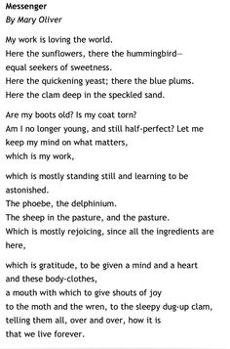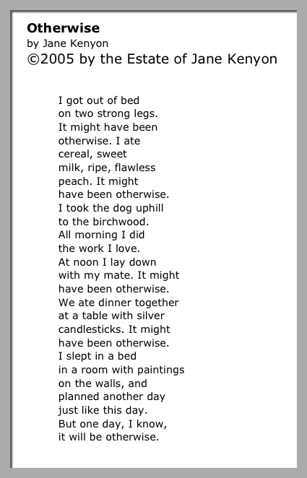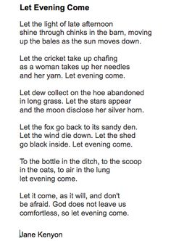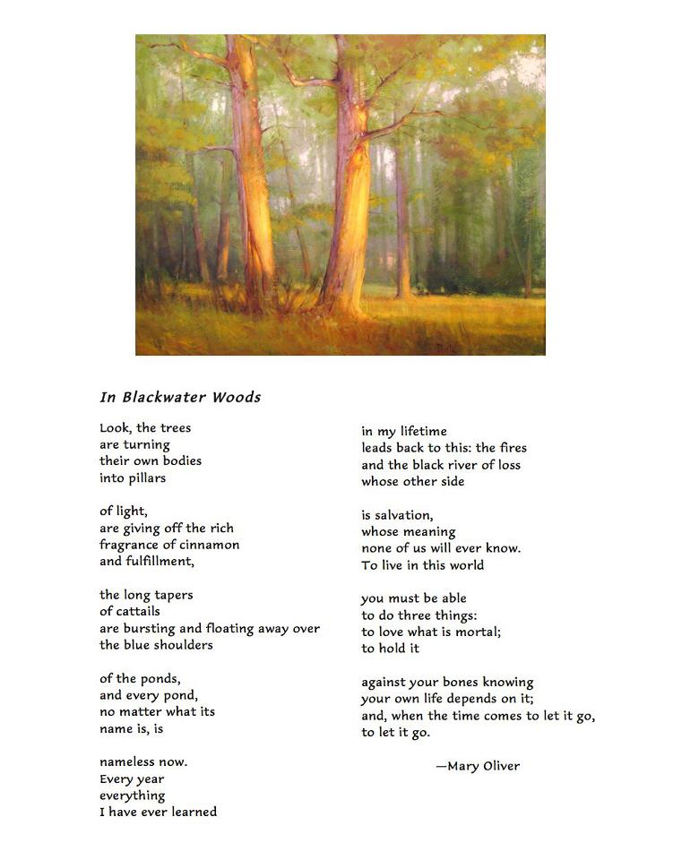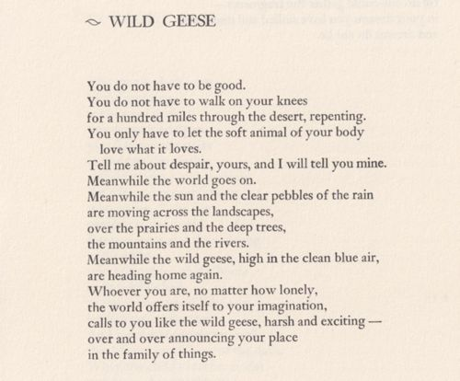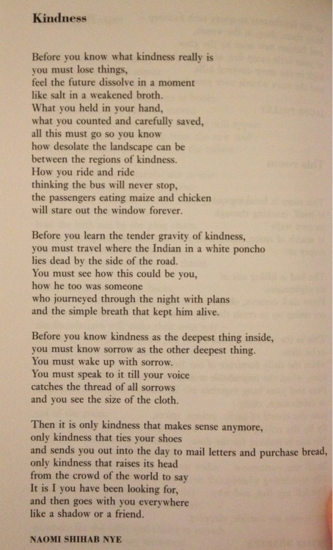
Above the Paradox Valley
By Rosemerry Trommer

You do not need to know what comes next.
There is always another storm, and you
cannot hang the tent out to dry before
it has gotten wet. You cannot shovel snow
that has yet to fall.

Put down the shovel. Breathe
into the dark spaces of your back,
feel how they open like cave doors
to let in the light.
Let your face soften. Let the creases
fall out of your brow. The mind,
no matter how clear, will never become
a crystal ball.

The wisest part of your body
knows to run when it hears
the first crashes of rock fall.
It does not pause then to consider
metamorphic or igneous,
nor does it hesitate to wonder
what might have pushed them down.
It is no small thing to trust yourself.

It’s okay to cry. It is right
that love should shake your body,
that you should find yourself trembling
in the rubble and dust
after all your certainties come down.

Your breath has not left you.
Here is the morning rain. It opens
the scent of the leaves, of the air.
All around you the world is changing.

What are you waiting for?
Here is the cup of mint tea
growing stronger in itself.
Here on this cliff of uncertainty
there is a stillness in you
so spirited, so alive
the wisest part of your body
is dancing.

_____________

After My Friend Phyllis Shows Me the New York Times Obituary Headline:
“Lou Michaels, All-Purpose Player, Dies at 80, Missed Kicks in ’69 Super Bowl”

by Rosemerry Trommer

When I die, let them write about
all the mistakes I’ve made.
Let them mention in the headlines
how many rejection letters
I’ve received from The Sun.
Let them say, “Missed her calling
for Broadway back in 1987.”
Let them say, “She trained hard, but
never won a Nordic skate race.”
They can note how my children
fought in front of company.
How every chocolate cake
I made sank in the center. How the beets
in my garden were never bigger
than golf balls. How I never even watched
the Super Bowl, much less
knew who played for the Colts
back in 1969 while I was still
forming in my mother’s womb
and Lou Michaels missed two
field goals that helped the Jets win.
What do any of us really accomplish?
My friend Wayne says,
“We do what we can
and have mercy.” Yes, let
them say I did what I could.
Let them say that I loved
the best I knew how and messed
that up, too. It’s what do,
we who are kicking our way
to the back pages of the paper.
Well-intentioned and foundering,
faithful and confused as we are,
we mess up. Yes, mercy on us,
mercy on all our failing little hearts,
how they beat so sincerely, mercy
on this longing to shine, this
reminder again to kneel.

